**Script for YouTube Video: Liskov Substitution Principle (LSP)**

**[Opening Sequence]**

[Show title screen with vibrant background music and the title: "Mastering the Liskov Substitution Principle in C#: Writing Reliable and Predictable Code"]

**[Introduction]**

**Host**: "Hey everyone! Welcome back to [Your Channel Name]. In today’s episode of our SOLID principles series, we’re talking about the **Liskov Substitution Principle**, or LSP."

**Host**: "This principle is all about ensuring that your derived classes can seamlessly replace their base classes without altering the behavior of your application. If you’re looking to write reliable and predictable code, this principle is a must-know!"

**Host**: "Stick around to see how we implement LSP in C# with some clear examples, and don’t forget to hit that like button and subscribe to stay updated with our SOLID series. Let’s get started!"

**[Part 1: What is the Liskov Substitution Principle?]**

**Host**: "The Liskov Substitution Principle is the third principle in SOLID. It states: ‘Objects of a superclass should be replaceable with objects of a subclass without affecting the correctness of the program.’"

[Display this text on-screen.]

**Host**: "In simpler terms, if you have a class hierarchy, the child classes should be able to stand in for their parent classes without breaking the application."

**[Part 2: Real-Life Analogy]**

[Show visuals of a vehicle hierarchy: Vehicle, Car, and Bicycle.]

**Host**: "Let’s use a real-life example. Imagine you’re designing a system for vehicles. You have a base class called Vehicle with a method Drive(). Now, if you create a Car class and a Bicycle class that inherit from Vehicle, both should behave appropriately when used as a Vehicle."

**Host**: "If the Drive() method in Bicycle suddenly tries to do something cars can’t handle—like requiring pedaling logic—you’ve broken LSP."

**[Part 3: Example of Violating LSP]**

[Switch to Visual Studio or your preferred IDE.]

**Host**: "Let’s look at an example in C#. Here’s a class hierarchy that violates the Liskov Substitution Principle."

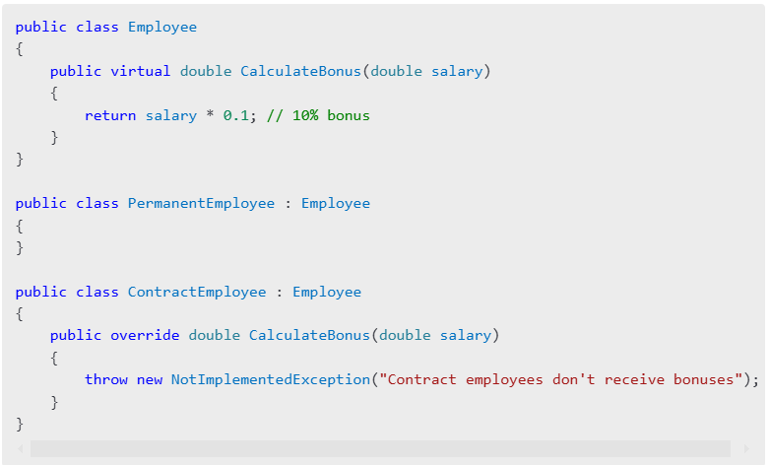

**Host**: "In this example, we have an Employee class with a CalculateBonus method. While it works fine for PermanentEmployee, the ContractEmployee class violates LSP because it overrides CalculateBonus to throw an exception. If we try to treat a ContractEmployee as an Employee, it will break our program’s behavior."

**[Part 4: Refactoring to Follow LSP]**

**Host**: "To fix this, we need to rethink our design. Instead of assuming all employees receive bonuses, we can introduce an interface or abstract class to handle bonus-specific behavior."

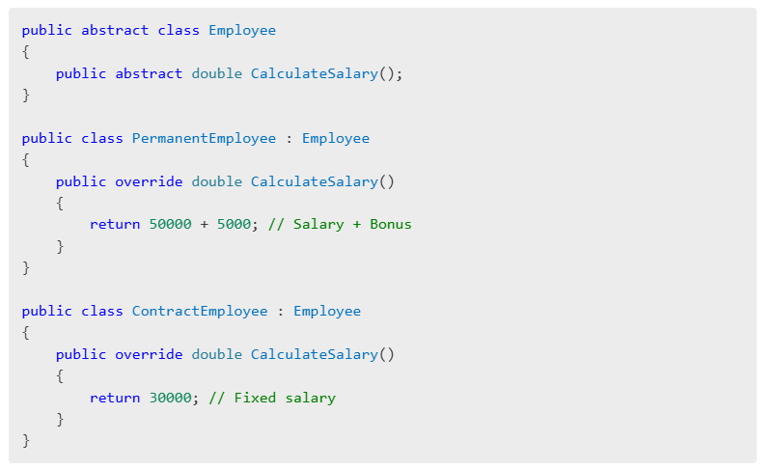

**Host**: "Now, the Employee class defines a more generic CalculateSalary method, and subclasses like PermanentEmployee and ContractEmployee implement it in ways that make sense for their behavior. This design adheres to LSP because no subclass breaks the contract of the base class."

**[Part 5: Advantages and Disadvantages of LSP]**

**Host**: "Now let’s quickly go over the advantages and disadvantages of following LSP."

**Advantages**:

* "Ensures your code is more predictable and reliable."
* "Encourages better design through meaningful abstractions."
* "Reduces the risk of runtime errors caused by incorrect assumptions."

**Disadvantages**:

* "Can require more upfront planning and design."
* "Might lead to over-abstraction if not applied wisely."

**[Part 6: Best Practices for Implementing LSP]**

**Host**: "Here are some best practices to keep in mind when applying LSP in your projects."

1. "Avoid creating methods or properties in the base class that may not make sense for all subclasses."
2. "Use interfaces or abstract classes to define behaviors."
3. "Always test substitutability to ensure derived classes work seamlessly in place of their base classes."

**[Part 7: Closing and Call-to-Action]**

**Host**: "To summarize, the Liskov Substitution Principle is about ensuring that your subclasses can be used anywhere their parent classes are expected, without unexpected behavior."

**Host**: "What do you think about LSP? Have you encountered situations where a subclass broke the behavior of your application? Share your experiences in the comments below."

**Host**: "If you enjoyed this video, give it a thumbs up and subscribe to [Your Channel Name] for more SOLID principles explained. And don’t forget to hit the bell icon to get notified about our next video on the **Interface Segregation Principle**!"

[End with upbeat music and your channel logo.]

**[On-Screen Text Suggestions]**

1. "Key Takeaway: Subclasses must replace their base classes without altering behavior."
2. "Best Practice: Use abstract classes or interfaces for behavior-specific designs."
3. "Up Next: Interface Segregation Principle."

**Suggested B-Roll and Visuals**

1. **Animations**: Show a contract employee trying to calculate a bonus with error visuals, then refactor to proper behavior.
2. **Text Popups**: Highlight key points during the code explanation.
3. **Flow Diagram**: Show a flowchart of class hierarchies before and after refactoring.

Let me know if you need further refinements or additional suggestions for this script!